Case Study 3:
Executing ls
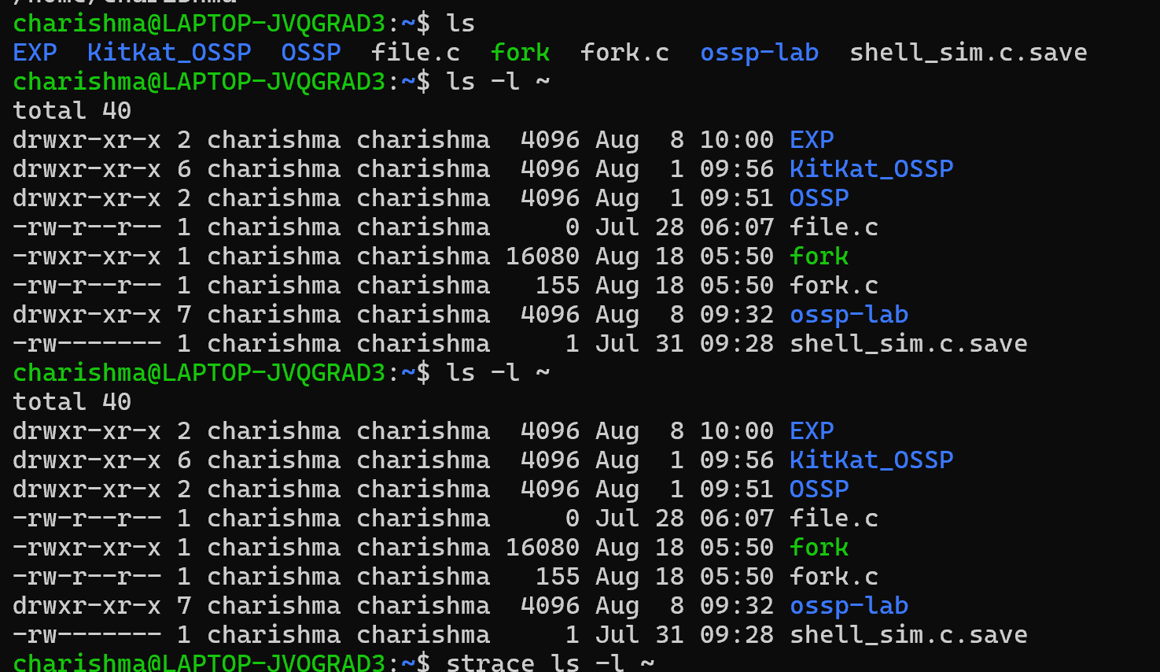
Result:
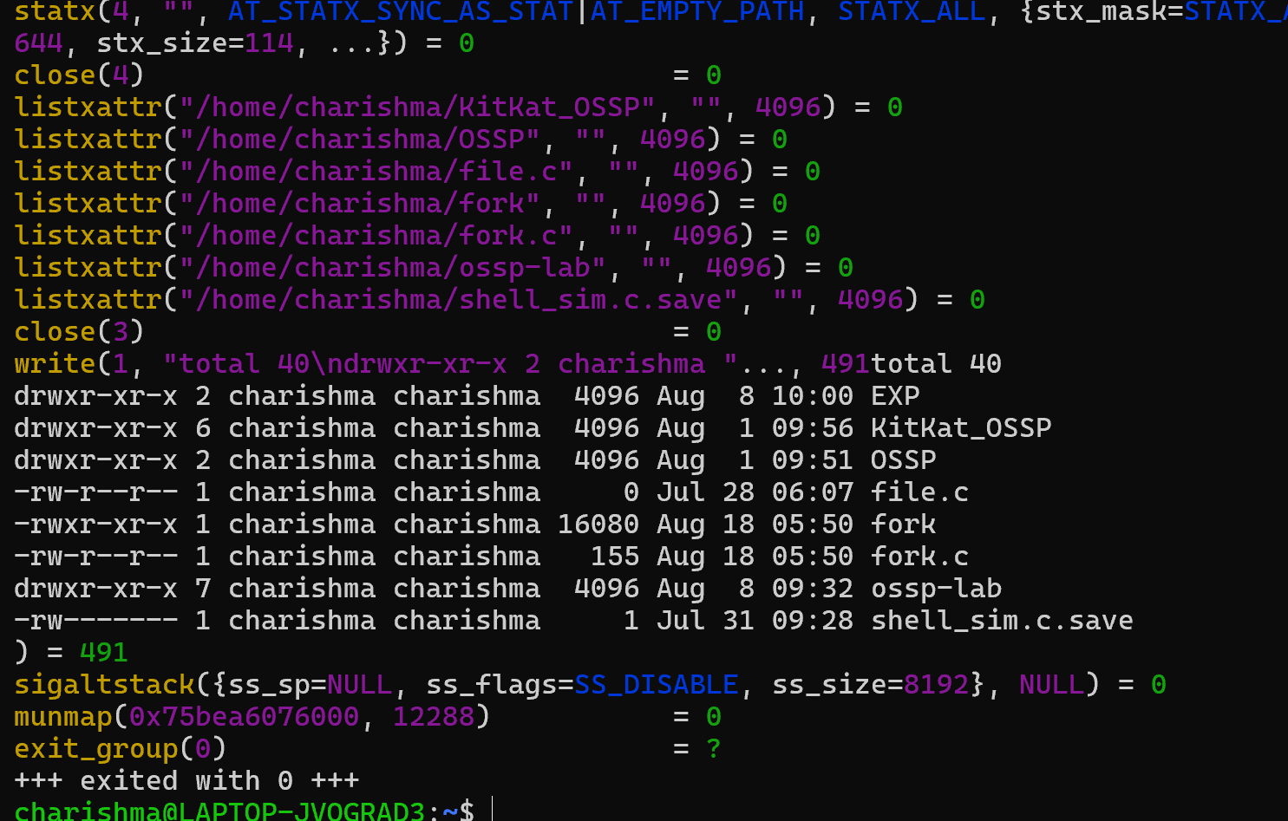
The ls command successfully displayed the directory information.

